02.92 LETTER OF REPRESENTATION

The following describes the functionality and features included in Probe Audit Premium+

Objective

The objective of this document is to obtain written representations from management confirming their responsibilities for the preparation of the financial statements, the completeness of information provided to the auditor, and specific assertions relevant to the audit, as required by ISA 580.

The following key concepts of the Probe Audit Premium+ Methodology are set in this document:
- Obtaining written representations from management confirming their responsibilities (ISA 580)
- Management’s confirmation that all relevant information and access has been provided for the audit
- Written representations as a necessary condition for issuing the audit report

Document placement

Document 02.92 – Letter of Representation can be found in the Client communication folder in the Caseware document manager.
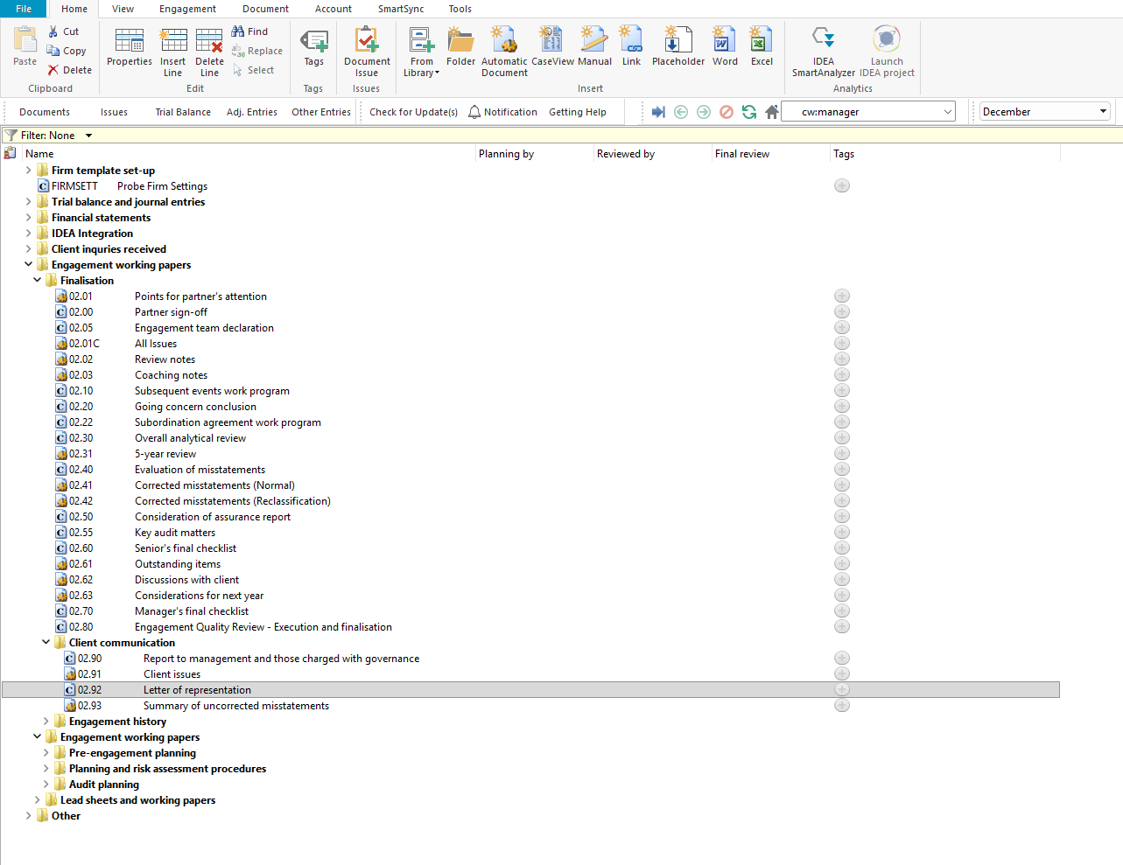

Document content

This document is designed to be a CaseView letter template that produces the written representation letter from management to the auditor. The document addresses the requirements of ISA 580 relating to written representations obtained from management as part of the audit evidence.

The letter contains twenty numbered representation sections covering the following topics:

Financial statements

Information provided

Laws and regulations

Litigations and claims

Related parties

Going concern

Subsequent events

Fraud

Uncorrected misstatements

Comparatives

Current assets

Property, plant and equipment

Impairment

Financial instruments

Financial institutions

Income tax

Contractual agreements

Encumbrances

Commitments

Financial statement disclosure
[Screenshot: Document map showing bookmarks]

Layout
Column | Input Required | Outcome
Letter header
Partner’s name | Pre-populated with the engagement partner’s name from the engagement file settings. | No impact on the engagement file.
Name of practice / firm | Pre-populated with the firm name from the engagement file settings. | No impact on the engagement file.
Salutation | Pre-populated with “Dear Sir(s)”. No input required. | No impact on the engagement file.
Introduction | Pre-populated introductory paragraph referencing the entity name, year-end date, and applicable financial reporting framework. No input required. | No impact on the engagement file.
General representations
Financial statements | Pre-populated representation confirming management’s responsibility for the preparation of the financial statements and that they are fairly presented in accordance with the applicable financial reporting framework. The engagement date field is pre-populated. No input required. | No impact on the engagement file.
Information provided | Pre-populated representation confirming that management has provided the auditor with access to all information, additional information requested, and unrestricted access to persons within the entity. No input required. | No impact on the engagement file.
Compliance and legal
Laws and regulations | Pre-populated representation confirming disclosure of all known instances of non-compliance with laws and regulations. No input required. | No impact on the engagement file.
Litigations and claims | Pre-populated representation confirming that the estimated effect of pending or threatened litigation and claims has been properly recorded or disclosed, and that no additional claims are expected. No input required. | No impact on the engagement file.
Relationships and going concern
Related parties | Pre-populated representation confirming disclosure of all related parties, related party relationships, and related party transactions. No input required. | No impact on the engagement file.
Going concern | Pre-populated representation confirming disclosure of all information relevant to the going concern assumption. No input required. | No impact on the engagement file.
Adjustments and events
Subsequent events | Pre-populated representation confirming that all events subsequent to the date of the financial statements have been adjusted for or disclosed. No input required. | No impact on the engagement file.
Fraud | Pre-populated representation confirming management’s responsibility for internal controls to prevent and detect fraud, disclosure of the results of management’s fraud risk assessment, and disclosure of all information relating to fraud or suspected fraud. No input required. | No impact on the engagement file.
Uncorrected misstatements | Pre-populated representation confirming that the effects of uncorrected misstatements are immaterial both individually and in the aggregate. No input required. | No impact on the engagement file.
Comparatives | Pre-populated representation confirming that no significant matters have arisen that would require a restatement of the comparatives. No input required. | No impact on the engagement file.
Assets and liabilities
Current assets | Pre-populated representation confirming that current assets have a value on realisation at least equal to the amounts stated, and that receivables represent valid claims with appropriate provisions. No input required. | No impact on the engagement file.
Property, plant and equipment | Pre-populated representation confirming the carrying values of property, plant and equipment, including additions, write-offs, and depreciation. No input required. | No impact on the engagement file.
Impairment | Pre-populated representation confirming that the carrying amount of assets has been reviewed for impairment and appropriate adjustments have been recorded. No input required. | No impact on the engagement file.
Financial instruments | Pre-populated representation confirming that all financial assets and liabilities have been reviewed and correctly classified, and that offsetting has not been applied unless explicitly permitted. No input required. | No impact on the engagement file.
Financial institutions | Pre-populated representation confirming that all financial institution accounts have been dealt with in the financial statements and that all necessary disclosures have been made. No input required. | No impact on the engagement file.
Other matters and disclosures
Income tax | Pre-populated representation confirming that the deferred tax valuation has been determined in accordance with the applicable financial reporting framework. No input required. | No impact on the engagement file.
Contractual agreements | Pre-populated representation confirming compliance with all contractual agreements and that all contractual arrangements have been properly reflected in the accounting records. No input required. | No impact on the engagement file.
Encumbrances | Pre-populated representation confirming satisfactory title to all owned assets and that no liens or encumbrances exist other than those disclosed. No input required. | No impact on the engagement file.
Commitments | Pre-populated representation confirming that no material commitments under contracts for capital expenditure, forward contracts, or foreign exchange exist other than those disclosed. No input required. | No impact on the engagement file.
Financial statement disclosure | Pre-populated representation confirming that various items have been properly recorded and disclosed in the financial statements, including sale and purchase commitments, assets pledged as collateral, off-balance-sheet activities, contingencies, and environmental matters. No input required. | No impact on the engagement file.
Sign-off
Closing and signature | Pre-populated closing text with “Yours faithfully” salutation and “Financial director” signature line. The letter is signed by the financial director on behalf of management. | No impact on the engagement file.

Document outcomes

The Letter header section provides the addressee details, firm name, salutation, and introductory paragraph for the representation letter. Entity-specific information such as the entity name, year-end date, and financial reporting framework is pre-populated from the engagement file settings.

The General representations section contains management’s confirmation of their responsibility for the preparation and fair presentation of the financial statements and the completeness of information provided to the auditor.

The Compliance and legal section covers representations relating to laws and regulations and litigations and claims, confirming that all known instances of non-compliance and the estimated effect of pending or threatened litigation have been disclosed.

The Relationships and going concern section covers representations relating to the identity and disclosure of all related parties and related party transactions, and the disclosure of all information relevant to the going concern assumption.

The Adjustments and events section covers representations relating to subsequent events, fraud, uncorrected misstatements, and comparatives, confirming that all relevant matters have been appropriately addressed and disclosed.

The Assets and liabilities section covers representations relating to current assets, property plant and equipment, impairment, financial instruments, and financial institutions, confirming that assets and liabilities have been properly valued, classified, and disclosed.

The Other matters and disclosures section covers representations relating to income tax, contractual agreements, encumbrances, commitments, and financial statement disclosure, confirming compliance and completeness of disclosures in the financial statements.

The Sign-off section contains the standard closing salutation and signature line for the financial director to sign on behalf of management.

Group Audits

When the engagement type was selected as ‘Group Audit Single’ or ‘Group Audit Multiple’, questions are modified for the separate group audit engagement file.

Additional questions were added for group audit engagement to:

Identify components for planning and performing of audit procedures;

Determine expected involvement of component auditors in risk assessment procedures and further audit procedures;

Evaluate access to components and component auditors; and

Determine whether there is any indication that the group auditor will not be able to be sufficiently and appropriately involved in the work of the component auditor.

Some questions include red warnings or blue text in the description column. Follow the red warnings that inform you where key information should be recorded and the blue text in the description column that advises you where the understanding may be documented.

IN CONCLUSION

Features

The following features are available in the document:

Insert or delete a comment, see page F3

Guidance, see page F16

Freeze, see page F19

